**Task**: Boot Camp on Aspose.Pdf

**Duration**: 2 days

**Prerequisites**

* Install PdfElement 6 Pro to edit pdfs
  + <http://download.wondershare.com/inst/pdfelement6-pro_setup_full2990.exe>

**Task**

* Alter DemoForm.pdf
  + Add a new section *Employment History*
    - Placed after Personal Information
    - This means Income Details now starts on page 2 to allow for employment history

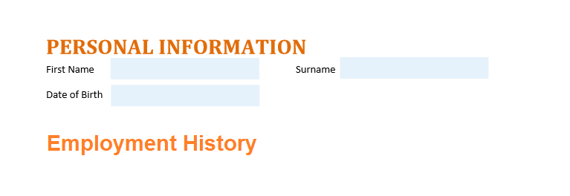

* Amend pdf-poc source
  + Make a branch with your name
  + Complete the following on your branch
    - Allow for up any number of employers to be listed in the employment history section
      * **Be sure to handle cases when the table runs onto page 2**
      * Use Aspose Tables to populate the employment history section
        + <https://docs.aspose.com/display/pdfnet/Manipulate+and+Integrate+Table#ManipulateandIntegrateTable-IntegrateTablewithDatabase(DOM)>
    - If no employers are present hide the Employment History header

**Hints**

* All documentation you need exist in the Aspose developer guide
  + <https://docs.aspose.com/display/pdfnet/Developer+Guide>